

+
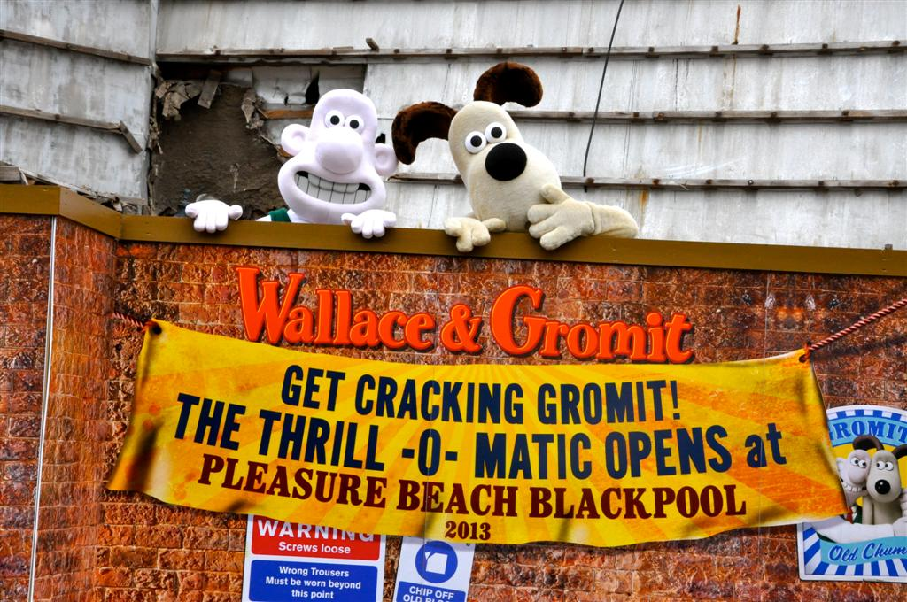

IT’S GOING TO BE A CRACKIN’ RIDE, PLEASURE BEACH!

Get ready to be stocked up on cheese because Wallace and Gromit are coming to Blackpool Pleasure Beach!

The Great British icons are to be the centerpiece of the new Thrill-O-Matic family ride which will replace the Gold Mine which closed at the end of the 2011 season.

The £5.25m investment is due to open in 2013 and will feature all the best-loved characters from the dynamic duo’s adventures.

Creators Aardman are working with Blackpool Pleasure Beach design and engineering team on the ride which will take a trip through A Grand Day Out, visit The Wrong Trousers, take A Close Shave and deal with A Matter of Loaf and Death.
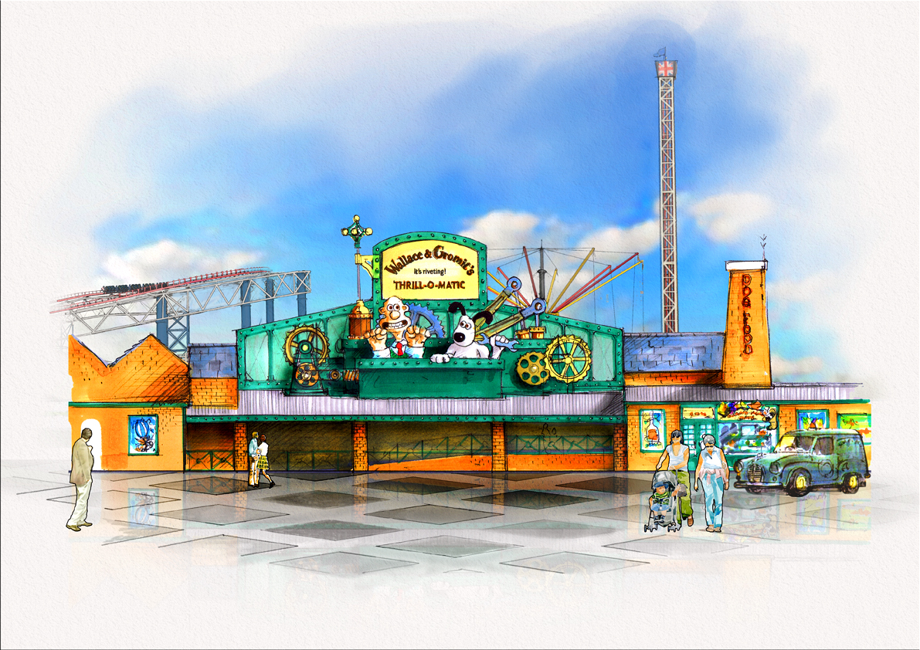
The ride takes almost four minutes and takes in dozens of well-loved scenes from the Wallace and Gromit films.

The riveting ride will also feature a shop where you can buy Wallace & Gromit merchandise.

Special hoardings featuring Wallace & Gromit are due to be erected at the site of Thrill-O-Matic as engineering work continues.

Blackpool Pleasure Beach managing director Amanda Thompson OBE said: “We are delighted to be welcoming Wallace & Gromit to Pleasure Beach.

“Thrill-O-Matic represents a significant investment in the park and we know the characters will be a huge hit with the families who come and visit Pleasure Beach.

“Wallace & Gromit are national treasures and to have them here re-affirms our commitment to attracting families back to the resort for what we hope will be A Grand Day Out!”

Nick Park, creator of Wallace and Gromit, said: “We are really enjoying working with the Pleasure Beach team on this new ride and new format for Wallace and Gromit and can’t wait to get started on building all the props and set pieces.”

PRESS INFORMATION
Issued by: Nick Hyde
Issue date: 24/05/2012
DD 01253 336330
Mobile 07584 515761
E-mail nick.hyde@bpbltd.com

Notes to editors:

Please find attached an artist impression of the frontage of Thrill-O-Matic and one of Wallace & Gromit on site at Pleasure Beach.

About Aardman

Aardman, based in Bristol (UK) co-founded and run by Peter Lord and David Sproxton, is a world leader in animation. It produces feature films, television series and television commercials for both the domestic and international market. Their multi-award winning productions are novel, entertaining, brilliantly characterised and full of charm that reflects the unique talent, energy and personal commitment of the very special people who make up the Aardman team. The studio’s work is often imitated and yet the company continues to lead the field producing a rare brand of visually stunning and amusing independent and commercials productions.
www.aardman.com

About Blackpool Pleasure Beach

Blackpool Pleasure Beach is a 42-acre amusement park featuring over 125 rides and attractions. It was established in 1896 by William G Bean and his great granddaughter, Amanda Thompson OBE is the current Managing Director and the fourth generation of the family to hold this position. www.pleasurebeachresort.com

